GENERAL MEAL GUIDELINES FOR PLAYERS
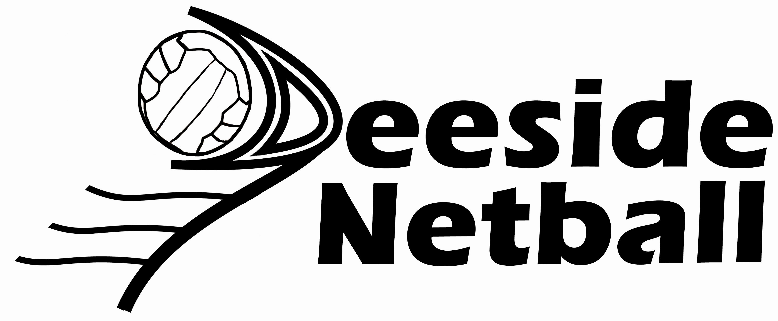
Breakfast – most important meal of the day
Cereals: Muesli; Weetabix; Cornflakes; Yoghurt.
Tinned Fruit: Peaches; Apricots; Plums; Pears
Bread: Wholemeal varieties
Fruit Juice: Orange; Pomegranate; Apple
Spreads: Jams; Marmalade; Honey; Marmite; Vegemite
Milk: Skimmed; Semi-skimmed

Lunches
Bread Rolls: variety of wholemeal, cheese etc.
Banana sandwiches
Pita Bread
Fillings: Cold meats, salmon, tuna, egg, beetroot, gherkins, tomatoes, low fat cheeses(edam), cottage cheese, pickles, chutneys, mussels
Salads: Variety especially pasta and rice slads
Muffins: Homemade or Supermarket
Crackers and pate, Muesli bars, dried fruits, yoghurt – low fat, tins of spaghetti, tins of sweetcorn, stuffed potatoes, pizza for a change on the odd day, noodles, rice dishes.

Dinners
Pasta dishes
Stuffed Potatoes
Cooked Chicken and vegetables
Roast lamb/beef/pork and vegetables
French sticks and bread rolls (not at all meals)
Rice dishes as an accompaniment
Soup as an accompaniment
Salads to accompany main meals
Desserts (not necessary)
Fresh fruit, especially bananas should be at all meals
Fresh fruit salads, rice puddings, bread and butter puddings (treat)

The Training Diet
Netballers gain their energy from carbohydrates (CHO) as this is the fuel supply for anaerobic activities. A diet high in CHO is necessary to constantly replenish the storage sites for glycogen; bloodstream, liver and muscles. Once these stores are depleted (after exercise), fatigue sets in. An added bonus with CHO is that they store water and therefore help offset dehydration.
BEFORE TRAINING/GAME eat a high CHO, low fat, no sugar meal that will digest easily and quickly. If unable to eat, try the CHO drinks that are available.
AFTER TRAINING/GAME and within the first hour, eat a high CHO, low fat meal. The body is at its most receptive to replace glycogen within the first hour. Some diluted fruit juice will help to bring blood sugar levels back to normal.

DRINK PLENTY OF WATER – ALWAYS BRING A LARGE BOTTLE OF WATER WITH YOU.
Cold water is absorbed quicker than warm water!!!
As players train to increase their skills, so must they train their bodies to accept food and water when it is most necessary!!

